1st International Conference and Innovation on Education and Science & technology 2024

Manuscript’s Title

Author’s Name1, Author’s Name2 & Author’s Name3

a1Institution, Postcode, City, State, Country

2Institution, Postcode, City, State, Country

3Institution, Postcode, City, State, Country

Abstract

Bilingual title, abstract, and keywords, i.e. in Malay and in English, need to be prepared as shown here with the Malay version followed by the English version. These must be prepared in Microsoft Word using Times New Roman. The font sizes should be 12-pt for the title, 10-pt for authors’ names, 9-pt for affiliations and e-mail addresses, and 8-pt for keywords. The abstract must be single-spaced, using 10-pt Times New Roman on A4 layout with margins of 3 cm width on both sides. It should not exceed 150 words. It should summaries the Introduction, objectives, methodology, findings, and conclusion of the research. Preferably the abstract contains no citations of the references or embedded equations.

***Keywords*:** *Type your keywords here, separated by semicolons [3-5 keywords]*

1. Main Text
   1. **Structure / Section headings**

Files must be in MS Word only. All text should be in Times New Roman, 10 pt. Follow this order when typing manuscripts:

* 1. **Tables**

All tables should be numbered with Arabic numerals. Every table should have a caption. Headings should be placed above tables, left justified. Tables must be embedded into the text and not supplied separately. Below is an example which the authors may find useful.

Table 1. An example of a table.

|  |  |  |
| --- | --- | --- |
| An example of a column heading | Column A (*t*) | Column B (*t*) |
| And an entry | 1 | 2 |
| And another entry | 3 | 4 |
| And another entry | 5 | 6 |

* 1. **Construction of references**

References must be listed at the end of the paper. Do not begin them on a new page unless this is necessary. Authors should ensure that every reference in the text appears in the list of references and vice versa. Indicate references by [1] or [2,3] in the text.

Some examples of how your references should be listed are given at the end of this template in the ‘References’ section, which will allow you to assemble your reference list according to the correct format and font size.

* 1. **Section headings**

Section headings should be left justified, bold, with the first letter capitalized and numbered consecutively, starting with the Introduction. Sub-section headings should be in capital and lower-case italic letters, numbered 1.1, 1.2, etc, and left justified, with second and subsequent lines indented. All headings should have a minimum of three text lines after them before a page or column break. Ensure the text area is not blank except for the last page.

1. Illustrations

All figures should be numbered with numerals (1,2,3,….). Please ensure that all the figures are of 300 DPI resolutions as this will facilitate good output. The figure number and caption should be typed below the illustration in 8 pt and left justified [***Note:*** one-line captions of length less than column width (or full typesetting width or oblong) centered]. For example, see Fig. 1.

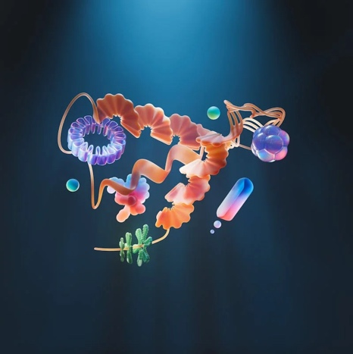

(a)

(b)

Fig. 1. (a) first picture; (b) second picture.

Acknowledgements

Acknowledgements and Reference heading should be left justified, bold, with the first letter capitalized but have no numbers. Text below continues as normal.

References

References should be formatted in a numbered reference style, and listed in the order in which they appeared in the artciel text. See examples below:

Please include DOIs for all journal articles.

[1] Authors name. (Year Published). Manuscript’s title. *Journal’s name,* Vol, page no. DOI No

[2] M.S. Haydar, D. Ghosh, S. Roy. (2024). Slow and controlled release nanofertilizers as an efficient tool for sustainable agriculture: Recent understanding and concerns. *Plant Nano Biol*ogy, 7, 100058. <http://dx.doi.org/10.1016/j.plana.2024.100058>

[3] Majumdar, A. (2020). Role of play in child development. *International Journal of Technical Research & Science*, *5*,(4), 9-16.

[10.30780/IJTRS.V05.I04.002](http://dx.doi.org/10.30780/IJTRS.V05.I04.002" \t "_blank)

**Author’s Checklist**

|  |  |
| --- | --- |
| **No.** | **Item** |
| 1. | *Title:*  Centered, Sentence case, Times New Roman, 17pts |
| 2. | *Author:*  Centered, Capitalized each word, Times New Roman, 13pts, mark affiliation with superscript letters |
| 3. | *Affiliation:* Centered, Italic, Times New Roman, 8pts |
| 4. | *Abstract:*  Times New Roman, 9pts, 100 – 150 words |
| 5. | *Keywords:*  Times New Roman, 10pts, 3-5 items |
| 6. | *Main text:*  Times New Roman, 10 pts, Single spacing, Justified |
| 7. | *Table:*  Caption example - Table 1. Caption, before table, Times New Roman, 8pts |
| 8. | *Reference:*  Use numbered style, eg. [1] |
| 9. | *Section headings:*  1.1, 1.2, etc |
| 10. | *Figure and illustrations:*  Caption example – Fig. 1. Caption, after image, Times New Roman, 8pts |
| 11. | *Bibliography:*  Numbered eg. [1], Abbreviated journal names, please check format  [1] Authors name. (Year Published). Manuscript’s title. *Journal’s name,* Vol, page no. DOI No  [2] M.S. Haydar, D. Ghosh, S. Roy. (2024). Slow and controlled release nanofertilizers as an efficient tool for sustainable agriculture: Recent understanding and concerns. *Plant Nano Biol*ogy, 7, 100058. <http://dx.doi.org/10.1016/j.plana.2024.100058>  [3] Majumdar, A. (2020). Role of play in child development. *International Journal of Technical Research & Science*, *5*,(4), 9-16.  [10.30780/IJTRS.V05.I04.002](http://dx.doi.org/10.30780/IJTRS.V05.I04.002) |
| 12. | *Manuscript length:*  4 to 8 pages |
| 13. | *Words counted:* 2000-5000 words |